Construction Traffic Management Plan
Hessay Solar Farm

Representative | Name | Job Title | Signature | Date
Prepared by: | Lee Onslow | Group SHE Manager | Lee Onslow
Approved by:
Issued to:
Works Completed:

Change record.

Minor amendments may be carried out by Ethical Power Ltd Site Manager named in this document, this must be recorded below and re-briefed to all engineers/operatives on site.

Major changes must be discussed and approved with the author of this document, prior to the works being undertaken. The CDM Plan must be re-briefed & re-signed by all parties’ concern.

Any significant changes to the Plan resulting from design changes will only be done after consultation with the Principal Designer.
Version | Revised By | Job Title | Reason for Change | Date
00 |  |  | Initial Draft based on pre-construction information

Contents

1. Introduction 3
2. Site Details 3
Fig. 1 Site Location – Primary Access 3
Fig. 2 Primary Access via Field 8, included in proposed site layout. 4
3. Development Proposals 5
4. Delivery Route 5
5. Site Arrival 6
6. Site Welfare and Construction Compound 6
Fig.3 PRoW / Bridleway locations adjacent to site: 7
7. Turning Facilities 7
8. Signage 7
9. Road Cleanliness and Dust suppression 8
10. Construction Traffic Movements 8
11. Operational Period 10
12. Mitigation 10
13. Conclusion 10

- Introduction

  - The CTMP provides details of the development proposal in the context of the site and its surroundings, the predicted construction traffic movements, and analysis of the impact on the local highway network, details of the site access and the measures that would be taken to mitigate the development proposal during the construction and decommissioning of the solar array.
  - The CTMP provides the framework for managing construction traffic and all contractors are expected to adhere to the requirements of the CTMP.

- Site Details

  - Agricultural Land to the South of Low Moor Lane Hessay, York, YO23 3RR.

Fig. 1 Site Location – Primary Access

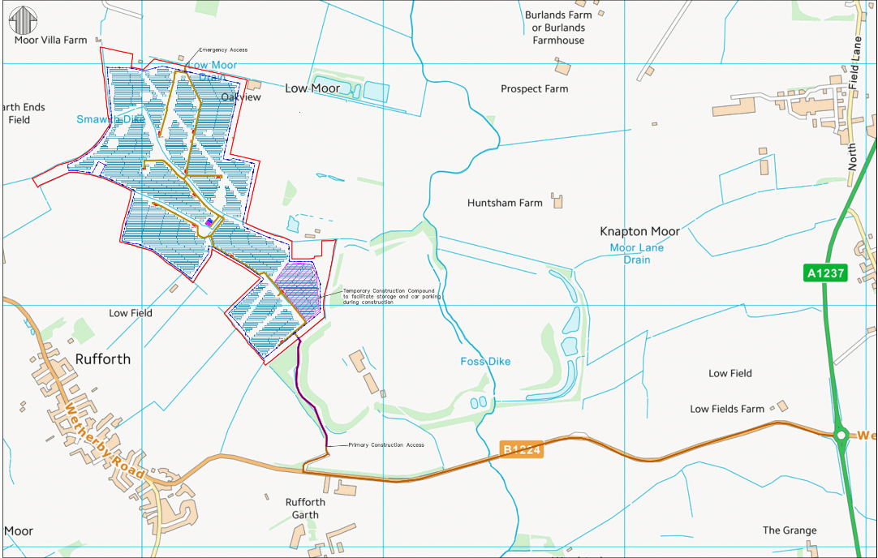

  - Hessay site comprises 61.3 hectares of agricultural land located in a rural setting, immediately South of Low Moor Lane, Hessay, Yorkshire. The land is currently used for agricultural purposes with no previous planning history. It is divided into 8 fields enclosed by native hedgerow.
The field complex is accessible from the south via Tinker Lane, leading from Height Lands Lane, B1224 and A1237 wider road network.
Although there is another entry point indicated, it is only suitable for emergency use.
Site access via Tinker Lane - What3Words///active.gaps.picturing

Fig. 2 Primary Access via Field 8, included in proposed site layout.

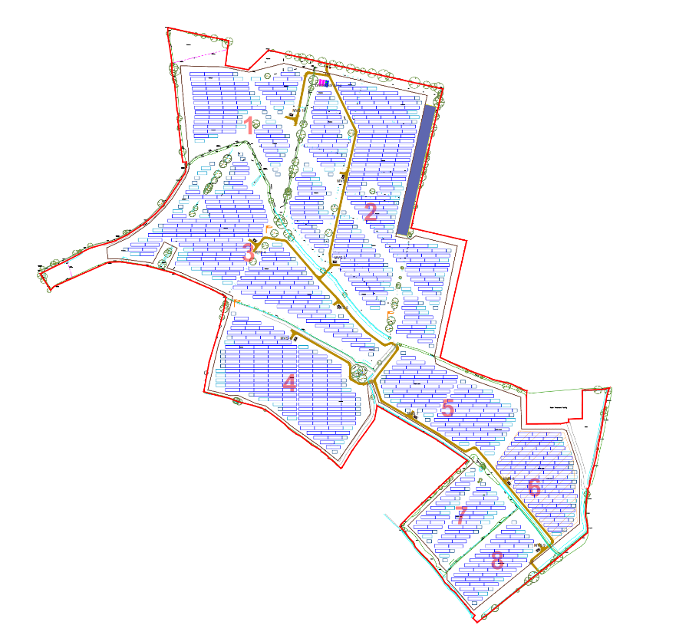

Site access is via field 8 (location shown above), the welfare compound will be constructed inside the entrance, where all visitors and deliveries must report to the gate security office on arrival for instructions regarding unloading, waiting, and parking locations.

- Development Proposals

  - The solar park development proposal consists of 32x 1.25MW Solar PV arrays connected through DC-AC converters to give a combined output capacity of 40MW. The maximum export into the Northern Powergrid network will be 42.1MVA and a maximum import of 335kVA. The site will be surrounded with a 2m high, steel mesh, stock proof fence, and monitored 24hour security CCTV system.

  - As per approved planning notices ref. 23/00626/FULM 6th April 2023 and NMA 25/01219/NONMAT, the development shall comply to the following pre-construction conditions, to be submitted to the LPA for approval before construction starts.

- Condition 6 – Details of surface water drainage (SuDS report)
- Condition 11 – Construction Environment Management Plan (CEMP)
- Condition 13 – Landscape Ecological Management Plan (LEMP)
- Condition 14 – Decommissioning Management Plan
- Condition 16 - Construction Traffic Management Plan (CTMP)
- Condition 17 – Construction access strictly only via Tinker Lane, except for emergency evacuation procedures.
To review full details of the planning conditions requirements, please refer to approval notices previously mentioned.

- Delivery Route

  - Delivery Control: The appointed contractor for the Proposed Development will be required to plan and manage deliveries and collections from the Proposed Development to minimise the impact on the surrounding road network and to minimise the impact on the local community. The contractor will ensure the following measures during the construction period:
  - Delivery of materials will not be within the morning and evening road network peaks, so far as possible, within reason.
  - The number of delivery trips will be minimised through a combination of consolidated ordering, rationalising suppliers, and consolidated deliveries.
  - On-site waste will be minimised through recycling and re-use; and
  - Note: With out exception and strictly in accordance with planning approval. Delivery vehicles will not route through the village of Rufforth.
  - All access into the site will be via Tinker Lane which is a private road of approximately 4.5m in width. It is accessed via Height Lands Lane (also a private road) which in turn connects with the B1224 (Wetherby Road). All construction vehicles and site deliveries will be via this access route with traffic coming in via the A1237 to the east of site, which has good road network access both north and south.
  - All construction vehicles, deliveries, and visitors, must report to the reception compound, security gate office off Tinkers Lane.
  - All construction deliveries will be escorted from the reception compound to the desired location within site for offload, ensuring that ground conditions are suitable for the activity.
  - Where possible a one-way route will be established to prevent clashes and reduce the need for reversing / turning.
  - Onward delivery may need to be conducted using smaller transport, equipment will be distributed within the site using appropriate vehicles.
  - Site Delivery route and all construction traffic movements: Will route from the East via the A1237 leading to the B1224, proceed through Height Lands Lane onto Tinker Lane, following information signage to the site entrance.

- Site Arrival

  - Drivers of vehicles suitable to be parked, will be provided with spaces located at the main compound. Vehicles shall be reversed parked into bays. Drivers shall report to the Site Manager and sign into site.
  - If space is not available, drivers are to be instructed to wait within their vehicles until called forward.
  - Delivery and Site Visitor Vehicles are not to be driven outside of designated areas of site, i.e. outside of the site compound / authorised vehicle routes.

- Site Welfare and Construction Compound
To construct the solar array a temporary construction compound will be set up inside the main entry point accessed from Tinker Lane.
  - The construction compound would be accessed by constructed temporary track for the Tinker Lane entrance.
  - The construction compound will comprise storage, offices, and welfare facilities including canteens and drying rooms. Parking for cars/vans will be provided for staff and visitors. Temporary welfare may be in place during the initial construction of the compound; this will be adequate for the number of people on site at the time of the works.
  - Welfare Provision will be in line with the requirements of schedule 2 of CDM regulations 2015.
  - A plan showing the layout of the compound, storage, parking, and traffic movement through the site will be established closer to the time.
  - Pedestrian crossings are provided between parking area and compound and the compound and site pedestrian access walkway.
  - Pedestrian walkway will be provided between the compound and the main construction area with segregation by way of crowd barriers.
  - Hessay site is accessed via a private single track road, Tinker Lane. Tinker Lane also accommodates a PRoW along its length before it crosses a further PRoW Bridleway adjacent to Hessay Solar Park site entrance. All construction vehicles will be required to cross both PRoW for the duration of the construction phase. Mitigation management procedures will be put in place. Designated crossing points will be identified for use by delivery and construction vehicles. This will include signage, safety barriers, and banksmen ensuring users of both PRoW have priority over construction traffic.

Fig.3 PRoW / Bridleway locations adjacent to site:
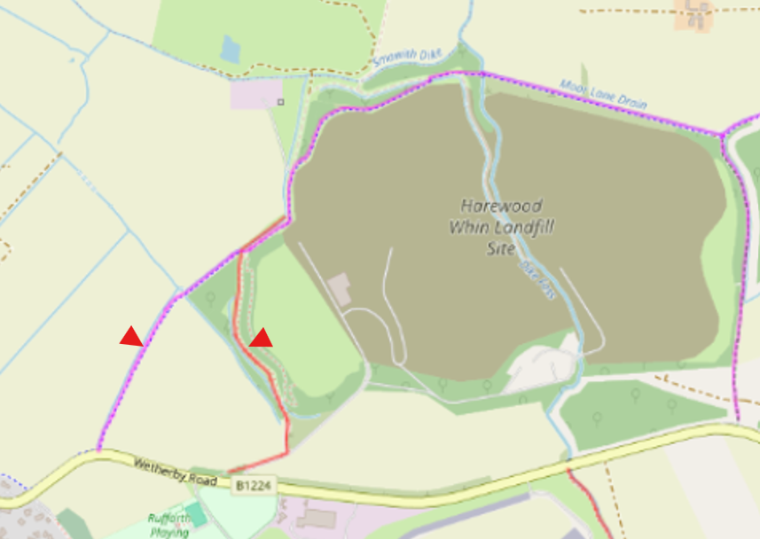

- Turning Facilities

  - The drop-off area will be large enough to accommodate up to 2 HGVs, if necessary, although under normal circumstances only one vehicle would be on-site at any one time.

- Signage

  - Temporary signage will be provided leading to Tinker Lane on the approach to the junction to warn drivers about the presence of construction traffic, PRoW’s, and additional temporary signs will be placed on approaches to provide information to drivers delivering to the site.
  - Traffic control signage on site, will be kept clean and maintained correctly. They must be checked as part of the installation road inspection and any remedial actions required are carried out promptly. Issues with any road or site signage must be reported immediately to the site manager.
  - Signage, both on and off site will include:

    - Countdown signs to site entrance.
    - Approach road (Tinker Lane) speed limit (15mph).
    - PRoW warning signs.
    - Site Entrance.
    - Site Exit.
    - Speed limit on site (5mph).

  - The site speed limit is strictly 5mph. Approach Road 15mph.

- Road Cleanliness and Dust suppression

  - The construction of the solar array does not involve major earthworks, but measures would be taken to suppress dust in dry, windy conditions by damping down the site, as necessary.
  - The access road, internal roads and the compound/drop-off area will be constructed from compacted road stone to limit the potential of vehicles transferring mud or other debris onto roads.
  - Wheel washing requirement will be assessed and provided based on conditions and the need, this will be located at the exit point to allow drivers to clean the wheels of their vehicles as required.
  - The construction materials for the solar array will be off-loaded by a telehandler and loaded directly onto a tractor and trailer, which will transport the materials within the site, to reduce transfer of mud and debris onto roads.
  - As required: A road sweeper would be hired when needed to sweep the roads in the vicinity of the site entrance/exit if weather conditions require additional measures to be taken to keep roads clear of mud and other debris.

- Construction Traffic Movements

  - The construction of the solar array will be carried out in 4 stages over 52 weeks following the approved construction programme.

Stage | Activity | Time
Stage 1 | Enabling Works:  - Compound  - Access track | 4 weeks
Stage 2 | Site Set Up:  - Site security  - Fencing  - Enabling works  - Delivery of plant + equipment | 4 weeks
Stage 3 | Solar Array Construction  - Erection of frames  - Solar panels  - Electrical Connections | 40 weeks
Stage 4 | Site Clearance  - Commissioning + testing  - Removal of offices/welfare  - Removal of compounds | 4 weeks

  - The working hours on the site would be between 08:00 to 19:00 Monday to Friday and between 08:00 to 13:00 on Saturdays.
  - No Abnormal traffic movements are expected to occur throughout the duration of site construction or operation.
  - During the initial stage of construction to secure the site, set up the temporary compounds, there will be about 10 site operatives on site which will increase to about 60 during the main construction stage phase and then drop off in the last weeks to about 20.
  - It is assumed that operatives working on the site will stay in the locality and will be transported to and from site by minibus, and there will be an average occupancy rate of five persons per vehicle or car share. Staff vehicles will consist of cars, light vans, or small commercial vehicles.
  - Staff will generally arrive by 07:30 and leave by 19:00 but there will inevitably be trips during the day to collect tools or visit local shops/banks, plus visitors etc. It has been assumed therefore that the number of daily staff movements will be multiplied by a factor of 1.25 to take account of these extra trips.
  - The chart below gives an approximate view of the maximum HGV/ Class 1 and 2 vehicles to access the site over an 8-month period.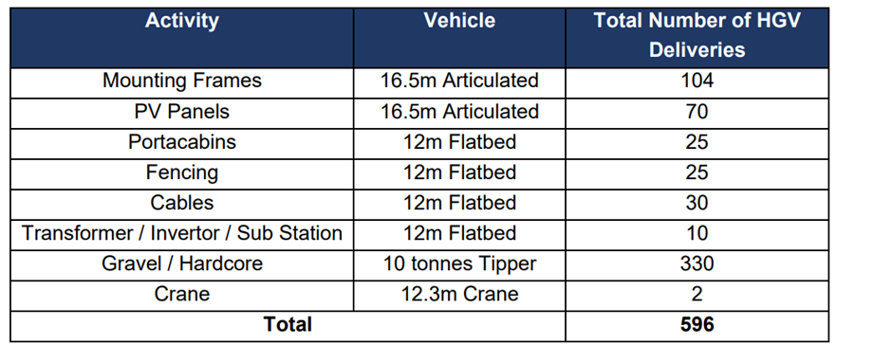

  - The maximum daily traffic flows that will access the site, including trips for deliveries + staff/visitor trips etc. will be 100 but this will be variable through different construction stages.
  - On the basis that the peak construction period would be less than 8 months, it is considered that there will be no residual impact on the local highway network and that the existing roads can accommodate the predicted peak and daily traffic flows.

- Operational Period

  - During the life of the solar array the only traffic movements will be from routine maintenance and repair vehicles which would amount to three to four trips a year. There would be no staff based on the site itself.
  - When the site reaches the end of its design life after about 40 years the solar array will be decommissioned and removed. The operation to decommission the equipment will be similar to the delivery and construction processes in Stage 2 and Stage 3.

- Mitigation

  - The working area needed to construct the solar array will be fully fenced and secured to protect the general public.
  - The main contractors will be issued with a copy of the CTMP and they will be expected to ensure that construction vehicles adhere to the route to the site.
  - Drivers would be instructed to call the site to give their expected time of arrival and to get clearance to deliver their load. Site Manager to manage the movement of delivery vehicles.
  - Defined work program and timeline.
  - Designated vehicle routes.
  - On-site parking and material storage.
  - Delivery scheduling and coordination.
  - Site security and environmental controls.
  - Signage: Temporary construction signage along routes.
  - Banksmen: To manage vehicle movements and prevent simultaneous arrivals.
  - Stop/Go Boards: Managed by banksmen on narrow lanes.
  - Highway Condition Survey: A pre-construction survey will be conducted.
  - Community Engagement: A Local Liaison Officer (LLO) will manage local communications and resolve unforeseen issues.

- Conclusion

  - The main contractors will be supplied with a copy of the CTMP and would be expected to fully implement the requirements to safely manage construction traffic movements.

